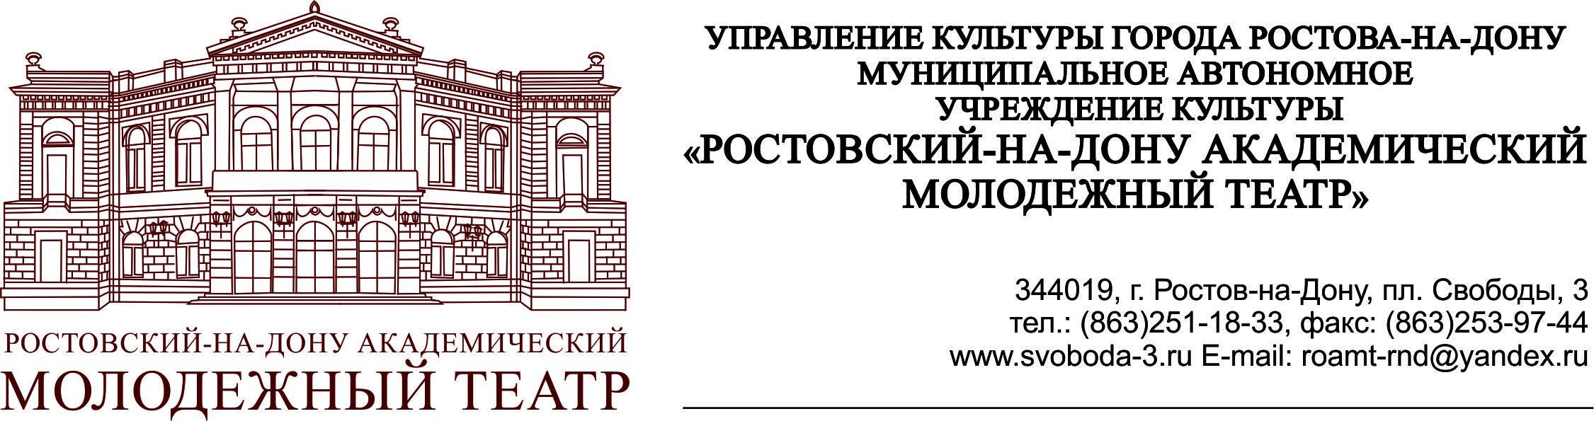

APPLICATION
For participation in the XIII International Theatre Festival «MINIFEST»
Rostov-on-Don – Russia

General information

- Country
- Name of the theatre
- Theatre director
- Contacts | - address:  - tel:  - fax:  - e-mail:  - web:
- Contact person
(+ mobile number)

Information about the show

- Name of the show
- Genre
- Director
- Author of the play or adaptation
- Stage designer
- Choreographer
- Costumer
- Composer, music
- Duration of the show and number of acts
- Resume of the show
(for the festival booklet)
- Language of the show
- Festivals, awards, etc.
- Link for a video of the entire show
- Link for a show trailer

Technical requirements

- Stage parameters:

- width
- depth
- height
- surface
- other requirements

- Light

- Sound

- Time for scene-shifter, light and sound tuning, rehearsal before the performance

- Time for dismantlement

- Other requirements

Travel details
- Number of travelling people_____ :

- Number of representatives of theatre administration___

- Number of actors: __________
Men ______ , Women_____ .

- Number of stage technicians: _________

- Desired transport:

- plane;
- train;
- bus;

- Total number of hotel rooms: ______
Number of single rooms: ______
Number of double rooms: ______
Number of triple rooms: ______

